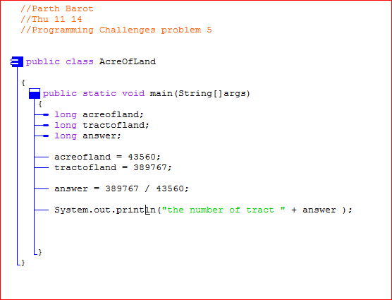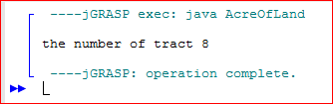Programming Challenges problem 7 input and output